**STATICS** ***UDM ENGR 3120*** - ***BUCT MEC 1701-1703*** ***CHAPTER 6 – Analysis of Structures*** Student Name……………….........

ASSIGNMENT # 6-1 Due on 16/12/19 Student # ………… Name ………………………….

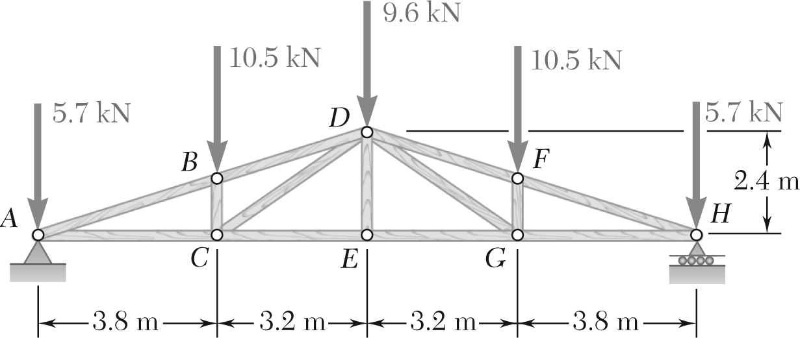

Determine the force in each member of the Pratt roof truss shown. State whether each member is in tension or compression